Sep 2026

Update the following Backlinks performance in the dashboard by considering the following parameters

Update the Number of URLS tracked, Total backlinks planned for Sep, actual backlinks acquired in Sep, and the number of keywords tracked to track performance

URLs Tracked - 45
PLAN TOTAL BACKLINKS (Sep) - 1220
Actual Total Backlinks (Sep) - 993
Keywords Tracked - 82

Here are the Referring DA categories of the given backlinks
Referring Domain DA
DA 71–100: 124
DA 41–70: 698
DA 30–40: 171

Business Impact of Backlinks

1. Impact on Keywords Where Backlinks Are Acquired

Keywords in Top 3 Positions
Dec’25 - 6
Sep’26 -18

Keywords on First Page
Dec’25 -35
Sep'26 - 44

2. Impact on Overall Keyword Rankings Graph
Page 1 Baseline - 41683 Sep - 46105 (Row 16)
Position 1 Baseline - 6085 Sep - 7172 (Row 13)
Position 2 & 3 Baseline - 10662 Sep - 12459 (Row 14)

Backlink Growth Analysis

Here are all the page URLs tracked

- https://www.fortinet.com/resources/cyberglossary/what-is-ztna
- https://www.fortinet.com/resources/cyberglossary/what-is-network-security
- https://www.fortinet.com/resources/cyberglossary/what-is-cybersecurity
- https://www.fortinet.com/resources/cyberglossary/sd-wan-explained
- https://www.fortinet.com/resources/cyberglossary/sase
- https://www.fortinet.com/resources/cyberglossary/firewall
- https://www.fortinet.com/resources/cyberglossary/what-is-cyber-attack
- https://www.fortinet.com/solutions/industries/scada-industrial-control-systems/what-is-ot-security
- https://www.fortinet.com/products/sd-wan
- https://www.fortinet.com/resources/cyberglossary/what-is-secops
- https://www.fortinet.com/resources/cyberglossary/ransomware
- https://www.fortinet.com/resources/hubs/quantum-security
- https://www.fortinet.com/resources/cyberglossary/what-is-cloud-security
- https://www.fortinet.com/resources/cyberglossary/casb
- https://www.fortinet.com/solutions/enterprise-midsize-business/fortiai
- https://www.fortinet.com/resources/cyberglossary/ai-security
- https://www.fortinet.com/resources/cyberglossary/cyber-threat-intelligence
- https://www.fortinet.com/resources/cyberglossary/artificial-intelligence-in-cybersecurity
- https://www.fortinet.com/resources/cyberglossary/application-security
- https://www.fortinet.com/resources/cyberglossary/cloud-data-protection
- https://www.fortinet.com/resources/cyberglossary/privileged-access-management
- https://www.fortinet.com/
- https://www.fortinet.com/blog/industry-trends/quantum-safe-encryption-safeguarding-data-for-the-quantum-era
- https://www.fortinet.com/blog/business-and-technology/cyber-risk-is-a-business-risk
- https://www.fortinet.com/blog/industry-trends/cybersecurity-in-banking
- https://www.fortinet.com/resources/articles/best-cloud-security-providers
- https://www.fortinet.com/resources/cyberglossary/network-monitoring
- https://www.fortinet.com/resources/cyberglossary/shors-grovers-algorithms
- https://www.fortinet.com/resources/cyberglossary/post-quantum-cryptography
- https://www.fortinet.com/resources/cyberglossary/quantum-computing-security
- https://www.fortinet.com/resources/cyberglossary/quantum-key-distribution
- https://www.fortinet.com/resources/cyberglossary/quantum-safe-security
- https://www.fortinet.com/resources/cyberglossary/quantum-security
- https://www.fortinet.com/resources/cyberglossary/what-is-soc
- https://www.fortinet.com/solutions/unified-sase
- https://www.fortinet.com/products/rugged
- https://www.fortinet.com/resources/cyberglossary/what-is-zero-trust
- https://www.fortinet.com/solutions/ai-security
- https://www.fortinet.com/solutions/cloud-security/enterprise
- https://www.fortinet.com/resources/cyberglossary/what-is-soar
- https://www.fortinet.com/products/siem/fortisiem
- https://www.fortinet.com/solutions/security-operations
- https://www.fortinet.com/resources/cyberglossary/malware
- https://www.fortinet.com/resources/cyberglossary/proxy-firewall
- https://www.fortinet.com/resources/cyberglossary/proxy-server

Here are the Months they are tracked for
Jan’26 Feb’26 Mar’26 Apr’26 May’26 Jun’26 Jul’26 Aug’26 Sep’26
Here are the Total Backlinks added, respectively, for each month
50
153
211
285
390
425
678
816
993

Keyword Ranking Performance
Keywords in the Top 3 Positions after acquiring backlinks in the month
Dec’25 - 6
Sep’26 -18

c

Performance Summary Table
Update the summary table using this data
Page URLs (45 Page URLs)
- https://www.fortinet.com/resources/cyberglossary/what-is-ztna
- https://www.fortinet.com/resources/cyberglossary/what-is-network-security
- https://www.fortinet.com/resources/cyberglossary/what-is-cybersecurity
- https://www.fortinet.com/resources/cyberglossary/sd-wan-explained
- https://www.fortinet.com/resources/cyberglossary/sase
- https://www.fortinet.com/resources/cyberglossary/firewall
- https://www.fortinet.com/resources/cyberglossary/what-is-cyber-attack
- https://www.fortinet.com/solutions/industries/scada-industrial-control-systems/what-is-ot-security
- https://www.fortinet.com/products/sd-wan
- https://www.fortinet.com/resources/cyberglossary/what-is-secops
- https://www.fortinet.com/resources/cyberglossary/ransomware
- https://www.fortinet.com/resources/hubs/quantum-security
- https://www.fortinet.com/resources/cyberglossary/what-is-cloud-security
- https://www.fortinet.com/resources/cyberglossary/casb
- https://www.fortinet.com/solutions/enterprise-midsize-business/fortiai
- https://www.fortinet.com/resources/cyberglossary/ai-security
- https://www.fortinet.com/resources/cyberglossary/cyber-threat-intelligence
- https://www.fortinet.com/resources/cyberglossary/artificial-intelligence-in-cybersecurity
- https://www.fortinet.com/resources/cyberglossary/application-security
- https://www.fortinet.com/resources/cyberglossary/cloud-data-protection
- https://www.fortinet.com/resources/cyberglossary/privileged-access-management
- https://www.fortinet.com/
- https://www.fortinet.com/blog/industry-trends/quantum-safe-encryption-safeguarding-data-for-the-quantum-era
- https://www.fortinet.com/blog/business-and-technology/cyber-risk-is-a-business-risk
- https://www.fortinet.com/blog/industry-trends/cybersecurity-in-banking
- https://www.fortinet.com/resources/articles/best-cloud-security-providers
- https://www.fortinet.com/resources/cyberglossary/network-monitoring
- https://www.fortinet.com/resources/cyberglossary/shors-grovers-algorithms
- https://www.fortinet.com/resources/cyberglossary/post-quantum-cryptography
- https://www.fortinet.com/resources/cyberglossary/quantum-computing-security
- https://www.fortinet.com/resources/cyberglossary/quantum-key-distribution
- https://www.fortinet.com/resources/cyberglossary/quantum-safe-security
- https://www.fortinet.com/resources/cyberglossary/quantum-security
- https://www.fortinet.com/resources/cyberglossary/what-is-soc
- https://www.fortinet.com/solutions/unified-sase
- https://www.fortinet.com/products/rugged
- https://www.fortinet.com/resources/cyberglossary/what-is-zero-trust
- https://www.fortinet.com/solutions/ai-security
- https://www.fortinet.com/solutions/cloud-security/enterprise
- https://www.fortinet.com/resources/cyberglossary/what-is-soar
- https://www.fortinet.com/products/siem/fortisiem
- https://www.fortinet.com/solutions/security-operations
- https://www.fortinet.com/resources/cyberglossary/malware
- https://www.fortinet.com/resources/cyberglossary/proxy-firewall
- https://www.fortinet.com/resources/cyberglossary/proxy-server

The following is the original data. I want you to add a + next to the Best Keyword Move column for all data in the dashboard (not here). Also, for Worst Keyword Move, I want you to subtract the last column from the first column( ex: For ZTNA 8-33= -25). I want you to do the same for all the rows here as well
For the given URLs above, here are the Total Backlinks, Ranking & Page Authority & Backlinks Added for months
Dec’25 Jan’26 Feb’26 Mar’26 Apr’26 May’26 June’26Jul’26Aug’26 Sep’26

Backlink Added 0 0 7 6 1 7 2 6 4 0
what is ztna 7 10 6 5 3 3 2 2 2 1
ZTNA 16 10 12 11 7 10 13 10 9 11
Page Authority 48 48 53 53 53 53 53 53 53 53

Total Baclinks 0 0 3 5 8 11 11 17 17 20
Backlink Added 0 0 3 2 3 3 0 6 0 3
what is network security 15 11 7 4 3 2 4 5 5 2
network security 13 14 10 8 6 4 10 14 13 8
Page Authority 53 53 53 53 53 53 53 53 53 53

Total Baclinks 0 0 4 6 10 16 16 21 21 26
Backlink Added 0 0 4 2 4 6 0 5 0 5
what is cybersecurity 11 13 10 9 10 10 10 12 12 11
cybersecurity 10 10 8 6 5 6 10 6 7 4
Page Authority 52 52 52 52 53 53 53 53 53 53

Total Baclinks 0 1 6 6 11 15 16 26 26 30
Backlink Added 0 1 5 1 4 4 1 10 0 4
What is SD WAN 8 7 6 5 4 3 2 3 3 2
sd wan 6 5 5 5 4 3 4 5 6 3
Page Authority 55 55 55 55 55 55 55 55 55 55

Total Baclinks 0 1 5 12 16 22 24 31 34 37
Backlink Added 0 1 4 7 4 5 3 7 3 3
sase 7 8 5 5 2 2 2 2 2 2
what is sase 11 12 8 6 3 2 2 2 2 1
Page Authority 56 56 56 56 56 56 56 56 56 56

Total Baclinks 0 0 4 6 8 11 12 21 29 39
Backlink Added 0 0 4 2 2 3 1 9 5 10
firewall 7 7 6 4 3 2 3 2 2 2
what is firewall 8 6 4 5 3 3 4 5 5 4
Page Authority 56 56 55 55 56 56 56 56 56 56

Total Baclinks 0 1 1 1 1 1 1 1 1 1
Backlink Added 0 1 0 0 0 0 0 0 0 0
what is cyber attack 8 7 1 2 2 2 2 3 2 2
cyber attack 7 8 9 8 6 6 6 8 9 8
Page Authority 50 50 51 51 51 51 51 51 51 51

Total Baclinks 0 1 4 5 7 12 12 24 24 27
Backlink Added 0 1 3 1 2 5 0 12 0 3
what is ot security 8 9 4 2 1 1 2 2 3 2
ot cyber security 5 11 4 3 4 5 12 22 11 5
ot security 9 9 5 4 2 2 2 2 2 2
Page Authority 55 55 55 55 55 55 55 55 55 55

Total Baclinks 0 1 1 1 1 5 5 13 18 30
Backlink Added 0 1 0 0 0 4 0 8 3 12
SD-WAN solutions 79 79 5 6 5 101 101 101 1 101
secure sd wan 16 15 2 1 1 1 1 4 5 6
Page Authority 59 59 59 59 59 59 59 59 59 59

Total Baclinks 0 0 5 6 11 15 21 27 34 37
Backlink Added 0 0 5 1 5 5 5 6 6 3
what is secops 22 17 7 3 4 2 2 2 5 1
secops 14 11 7 6 6 7 9 9 5 5
Page Authority 48 48 49 49 50 50 50 50 50 50

Total Baclinks 0 2 2 2 2 2 2 2 2 2
Backlink Added 0 2 0 0 0 0 0 0 0 0
what is ransomware 9 8 7 7 8 8 6 7 8 7
ransomware 7 6 7 5 4 6 7 8 9 8
Page Authority 56 56 57 57 57 57 57 57 57 57

Total Baclinks 0 0 1 2 2 2 2 2 2 2
Backlink Added 0 0 1 1 0 0 0 0 0 0
quantum security solutions 101 101 101 101 101 101 101 101 101 101
quantum security 101 1 101 101 1 101 101 101 101 101
Page Authority 41 41 43 43 44 44 44 44 44 44

Total Baclinks 0 4 23 31 44 53 54 68 94 112
Backlink Added 0 4 19 8 13 9 1 14 22 18
what is cloud security 19 15 13 9 12 17 16 16 23 15
cloud security 17 17 18 14 16 19 21 19 20 22
Page Authority 49 49 51 51 52 52 52 52 52 52

Total Baclinks 0 2 2 2 2 2 2 2 2 2
Backlink Added 0 2 0 0 0 0 0 0 0 0
casb 10 9 7 4 5 4 6 5 7 7
casb security 18 18 9 4 6 8 8 10 8 7
Page Authority 49 49 49 49 50 50 50 50 50 50

Total Baclinks 0 2 2 2 2 2 3 8 8 11
Backlink Added 0 2 0 0 0 0 1 5 0 3
ai cybersecurity solutions 101 101 101 101 101 101 101 101 101 101
ai managed security 101 101 101 101 101 101 101 101 101 101
Page Authority 49 49 37 37 52 52 52 52 52 52

Total Baclinks 0 12 15 16 18 20 21 28 30 31
Backlink Added 0 12 3 1 2 2 0 8 2 1
AI Security 8 10 11 8 12 18 16 11 11 9
what is ai security 7 7 8 10 11 12 14 13 8 5
AI Security systems 8 8 17 9 10 8 6 6 5 5
Page Authority 52 52 53 53 53 53 53 53 53 53

Total Baclinks 0 12 12 12 12 12 12 12 12 12
Backlink Added 0 12 0 0 0 0 0 0 0 0
Threat Intelligence 25 23 31 18 18 16 18 19 14 12
Types of threat intelligence 101 101 101 28 101 101 101 42 101 101
Page Authority 48 48 49 49 49 49 49 49 49 49

Total Baclinks 0 0 6 8 12 16 23 41 49 55
Backlink Added 0 0 6 2 4 4 2 23 6 6
AI Cybersecurity 3 3 4 3 3 3 5 2 2 3
role of ai in cyber security 101 14 101 101 2 1 2 1 1 1
Page Authority 55 55 55 55 55 55 55 55 55 55

Total Baclinks 0 2 2 2 2 2 2 2 2 2
Backlink Added 0 2 0 0 0 0 0 0 0 0
Application Security 18 19 16 18 16 16 20 20 26 16
Application security definition 14 19 17 5 5 4 5 7 8 8
Page Authority 41 41 46 46 46 46 46 46 46 46

Total Baclinks 0 1 5 7 9 13 13 17 25 32
Backlink Added 0 1 4 2 2 4 0 4 7 7
Cloud Data Security 66 62 31 25 34 40 35 29 47 47
cloud data protection 21 18 12 9 16 38 29 25 26 26
Page Authority 43 43 46 46 47 47 47 47 47 47

Total Baclinks 0 4 4 4 4 4 4 4 4 4
Backlink Added 0 4 0 0 0 0 0 0 0 0
Privileged Access Management 12 14 16 10 13 13 12 12 13 11
PAM 5 6 3 6 101 101 5 7 8 9
Page Authority 48 48 48 48 48 48 48 48 48 48

Total Baclinks 0 1 2 2 3 8 8 16 23 24
Backlink Added 0 1 1 0 1 5 0 8 7 1
Cybersecurity 86 89 86 67 35 27 29 12 16 11
What is Cybersecurity 101 101 101 101 101 101 101 101 101 101
Page Authority 68 68 69 69 69 69 69 69 69 69

Total Baclinks 0 0 2 3 4 6 6 12 13 14
Backlink Added 0 0 2 1 1 2 0 6 1 1
Quantum safe encryption for crytography 101 101 101 101 101 101 101 101 101 101
Quantum Safe Encryption 5 4 101 3 4 29 14 101 7 6
Page Authority 60 60 47 47 47 47 47 47 47 47

Total Baclinks 0 2 2 2 2 2 2 2 2 2
Backlink Added 0 2 0 0 0 0 0 0 0 0
cyber risk 40 41 40 32 37 101 50 101 81 101
cyber risk is business risk 101 101 101 101 101 101 101 101 101 101
Page Authority 44 44 46 46 46 46 46 46 46 46

Total Baclinks 0 1 1 1 1 1 1 1 1 1
Backlink Added 0 1 0 0 0 0 0 0 0 0
cybersecurity in banking 101 30 101 12 21 25 29 7 9 101
banking cybersecurity 101 101 101 3 101 28 101 14 22 101
Page Authority 44 44 44 44 46 46 46 46 46 46

Total Baclinks 0 0 7 8 17 17 17 17 17 17
Backlink Added 0 0 7 1 9 0 0 0 0 0
cloud security vendors 9 7 11 6 8 7 8 5 5 6
cloud security providers 5 7 9 5 8 9 3 8 7 6
Page Authority 61 61 61 61 44 44 44 44 44 44

Total Baclinks 0 0 3 4 7 11 11 14 14 18
Backlink Added 0 0 3 1 3 4 0 3 0 4
network monitoring 21 19 11 7 8 12 13 11 10 4
network monitoring system 29 19 19 14 11 10 10 4 4 3
Page Authority 44 44 44 44 45 45 45 45 45 45

Total Baclinks 0 0 3 5 6 9 11 20 24 27
Backlink Added 0 0 3 2 1 3 2 9 2 3
grover's algorithm 6 7 7 4 8 4 5 2 101 101
shors algorithms 101 101 101 101 101 101 101 101 101 101
Page Authority 46 46 47 47 47 47 47 47 47 47

Total Baclinks 0 0 4 6 7 10 11 18 22 25
Backlink Added 0 0 4 2 1 3 1 7 4 3
pqc 10 11 11 5 7 14 16 16 8 9
Post-Quantum Cryptography 1 2 3 6 2 2 3 4 3 6
Page Authority 39 39 42 42 44 44 44 44 44 44

Total Baclinks 0 0 2 4 5 6 8 12 14 15
Backlink Added 0 0 2 2 1 1 1 5 2 1
Quantum Computing Security 101 4 5 6 101 7 4 1 2 1
Page Authority 46 47 47 47 47 47 47 47 47 47

Total Baclinks 0 0 1 5 5 6 10 15 19 22
Backlink Added 0 0 1 4 0 1 4 5 4 3
Quantum Key Distribution 4 8 8 5 4 5 5 4 2 3
Page Authority 61 61 61 61 44 44 44 44 44 44

Total Baclinks 0 0 2 3 5 7 8 12 13 14
Backlink Added 0 0 2 1 2 2 0 5 1 1
Quantum Safe Security 3 1 1 101 101 2 101 1 3 1
Page Authority 37 39 40 40 42 42 42 42 42 42

Total Baclinks 0 0 5 6 7 9 10 16 16 18
Backlink Added 0 0 4 2 1 2 1 6 0 2
Quantum Security 8 7 5 5 5 4 3 5 5 6
Page Authority 41 40 40 40 44 44 44 44 44 44

Total Baclinks 0 0 2 3 4 6 7 8 10 12
Backlink Added 0 0 2 1 1 2 1 1 2 2
Security Operation Centre 101 101 101 101 101 101 101 101 101 101
Page Authority 51 52 52 52 52 52 52 52 52 52

Total Baclinks 0 0 2 3 3 8 13 24 35 51
Backlink Added 0 0 2 1 0 6 4 11 9 16
Unified SASE 1 1 1 1 1 6 3 3 1 1
Page Authority 37 40 41 41 44 44 44 44 44 44

Total Baclinks 0 0 2 5 6 8 10 12 15 21
Backlink Added 0 0 2 3 1 2 2 2 3 6
Ruggedized firewall 101 1 1 1 101 1 1 1 1 101
industrial firewall 2 2 1 3 1 1 1 20 101 101
Page Authority 44 44 44 44 44 44 44 44 44 44

Total Baclinks 0 0 0 0 4 5 6 15 29 47
Backlink Added 0 0 0 0 4 1 1 9 10 18
What is Zero Trust 101 101 101 101 101 101 101 49 46 31
Zero trust 101 101 101 61 57 24 101 59 68 74
Page Authority 42 42 42 42 42 42 42 42 42 42

Total Baclinks 0 0 0 0 2 4 4 4 4 4
Backlink Added 0 0 0 0 2 2 0 0 0 0
AI Security 101 57 36 19 28 35 101 63 8 23
Page Authority 43 43 43 43 43 43 44 44 44 44

Total Baclinks 0 0 0 0 0 6 6 14 26 51
Backlink Added 0 0 0 0 0 6 0 8 8 25
Cloud Security Services 101 101 101 101 101 101 101 101 101 101
Cloud Security Solutions 101 101 101 101 101 101 101 101 101 101
Page Authority 37 37 37 37 37 39 41 41 41 41

Total Baclinks 0 0 0 0 0 0 1 3 5 6
Backlink Added 0 0 0 0 0 0 1 2 2 1
soar automation 2 3 1 4 1 4 10 5 3 5
Page Authority 61 61 61 61 61 61 61 61 61 61

Total Baclinks 0 0 0 0 0 0 0 11 24 34
Backlink Added 0 0 0 0 0 0 0 11 10 10
siem software 15 12 11 9 4 6 11 15 13 14
siem products 8 12 9 8 8 10 9 10 11 9
siem solution 11 11 8 4 3 7 11 11 8 8
Page Authority 61 61 61 61 61 61 61 61 61 61

Total Baclinks 0 0 0 0 0 0 0 5 10 17
Backlink Added 0 0 0 0 0 0 0 5 4 7
security operations solution 101 101 101 101 101 101 101 101 101 101
secops solutions 101 101 101 101 101 101 101 101 101 101
Page Authority 37 37 37 41 43 43 42 43 43 43

Total Baclinks 0 0 0 0 0 0 0 0 0 2
Backlink Added 0 0 0 0 0 0 0 0 0 2
Malware 8 9 7 8 6 7 11 7 12 13
Page Authority 61 61 61 61 61 61 61 61 61 61

Total Baclinks 0 0 0 0 0 0 0 0 0 2
Backlink Added 0 0 0 0 0 0 0 0 0 2
Proxy Firewall 6 9 6 N/A N/A N/A N/A N/A N/A N/A
Page Authority 53 53 53 53 53 53 53 53 53 54

Total Baclinks 0 0 0 0 0 0 0 0 0 1
Backlink Added 0 0 0 0 0 0 0 0 0 1
Proxy server N/A N/A N/A N/A N/A N/A N/A N/A N/A
Page Authority 58 58 58 58 58 58 58 58 59 59

Key Findings
Include key findings from the data Insights

Insights
- Key Findings
- High-Quality Domain Profile: 70.3% of acquired referring domains fall in the DA 41–70 range (698 domains), representing the largest share of the portfolio. 17.2% are in the DA 30–40 range (171 domains), while 12.5% are high-authority DA 71–100 domains (124 domains). Overall, 82.8% of referring domains have a DA of 41 or higher, indicating a strong authority profile.
- Keyword Visibility: From December 2025 to September 2026, Top 3 rankings grew 200% (from 6 to 18), and Page 1 rankings grew 25.7% (from 35 to 44).
- Page Authority (PA) as a Leading Indicator: PA has improved for several other pages, such as Security Operations (37 → 43), Quantum Safe Security (37 → 42), Cloud Security Enterprise (37 → 41), Cyber Risk is a Business Risk (44 → 46), Cybersecurity in Banking (44 → 46), Cybersecurity (68 → 69 ), Cyber Threat Intelligence (48 → 49), and Quantum Computing Security (46 → 47).
- Significant Keyword Improvement: The keywords what is ZTNA (1), what is SASE (1), what is SecOps (1), role of AI in cyber security (1), Quantum Computing Security (1), Quantum Safe Security (1), What is SD WAN (2), What is Cyber Attack (2), what is network security (2), and network monitoring system (3) showed significant improvement in search ranking.
- Strong Backlink Quality: 73% of acquired backlinks are indexed, showing healthy discovery and indexing performance.

Backlink Acquisition Details
Fortinet: Monthly Backlink 2026
SERP Key Highlights:
Priority Category pages - What is SASE, What is Network Security, and Cyber Attack - moved into Page 1 positions following backlink-driven ranking improvements.

Keyword - what is sase
Link - https://www.fortinet.com/resources/cyberglossary/sase
Position - 4
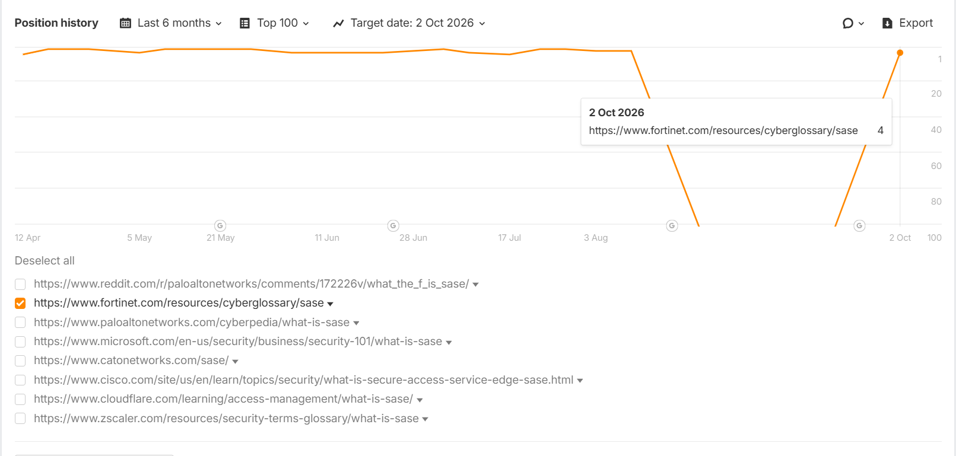

Insight: The "What is SASE" keyword has secured a Page 1 position at #4, with consistent backlink acquisition strengthening the page's authority and bringing it within reach of the Top 3.

Keyword - what is network security
Link - https://www.fortinet.com/resources/cyberglossary/what-is-network-security
Position - 1
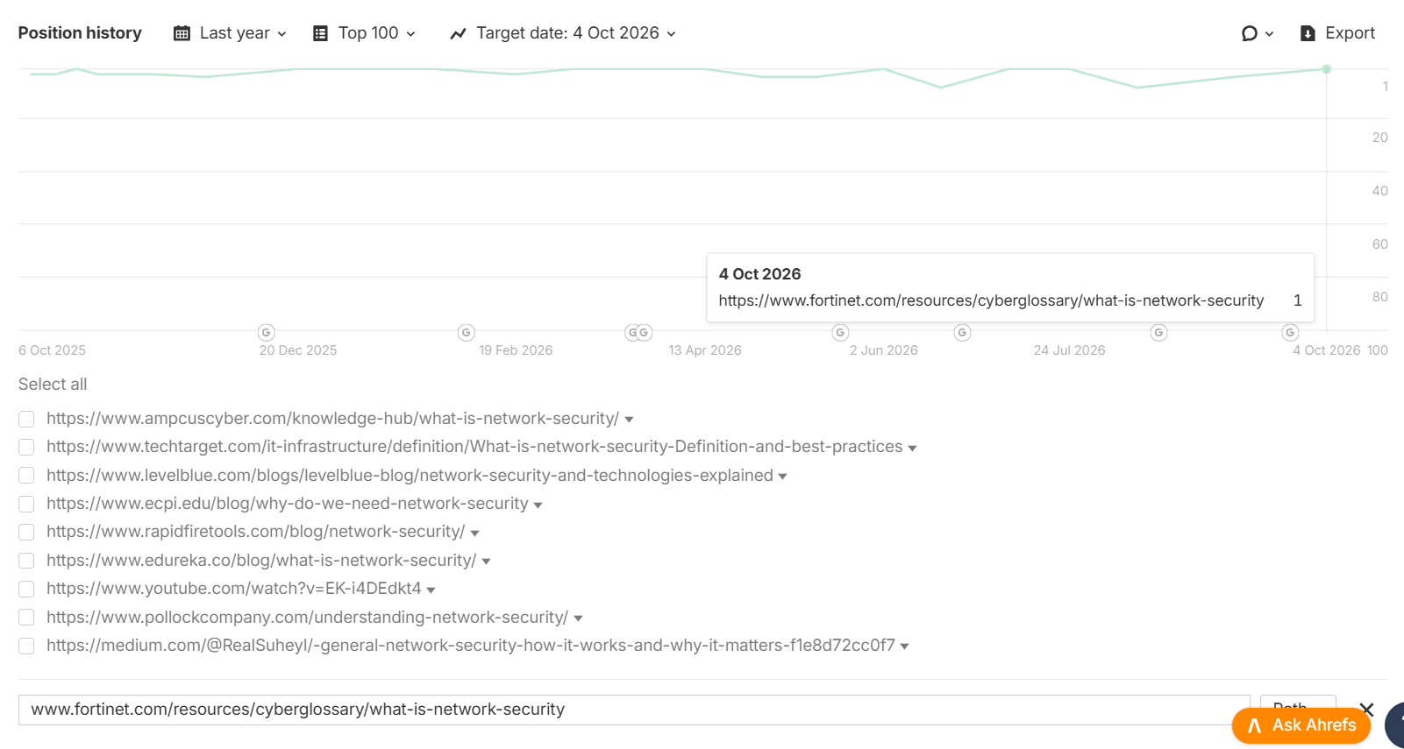
Insight: The "What is Network Security" keyword has climbed to the #1 position, consolidating its Page 1 presence after sustained backlink acquisition throughout the campaign.

Keyword - cyber attack
Link - https://www.fortinet.com/resources/cyberglossary/what-is-cyber-attack
Position - 1
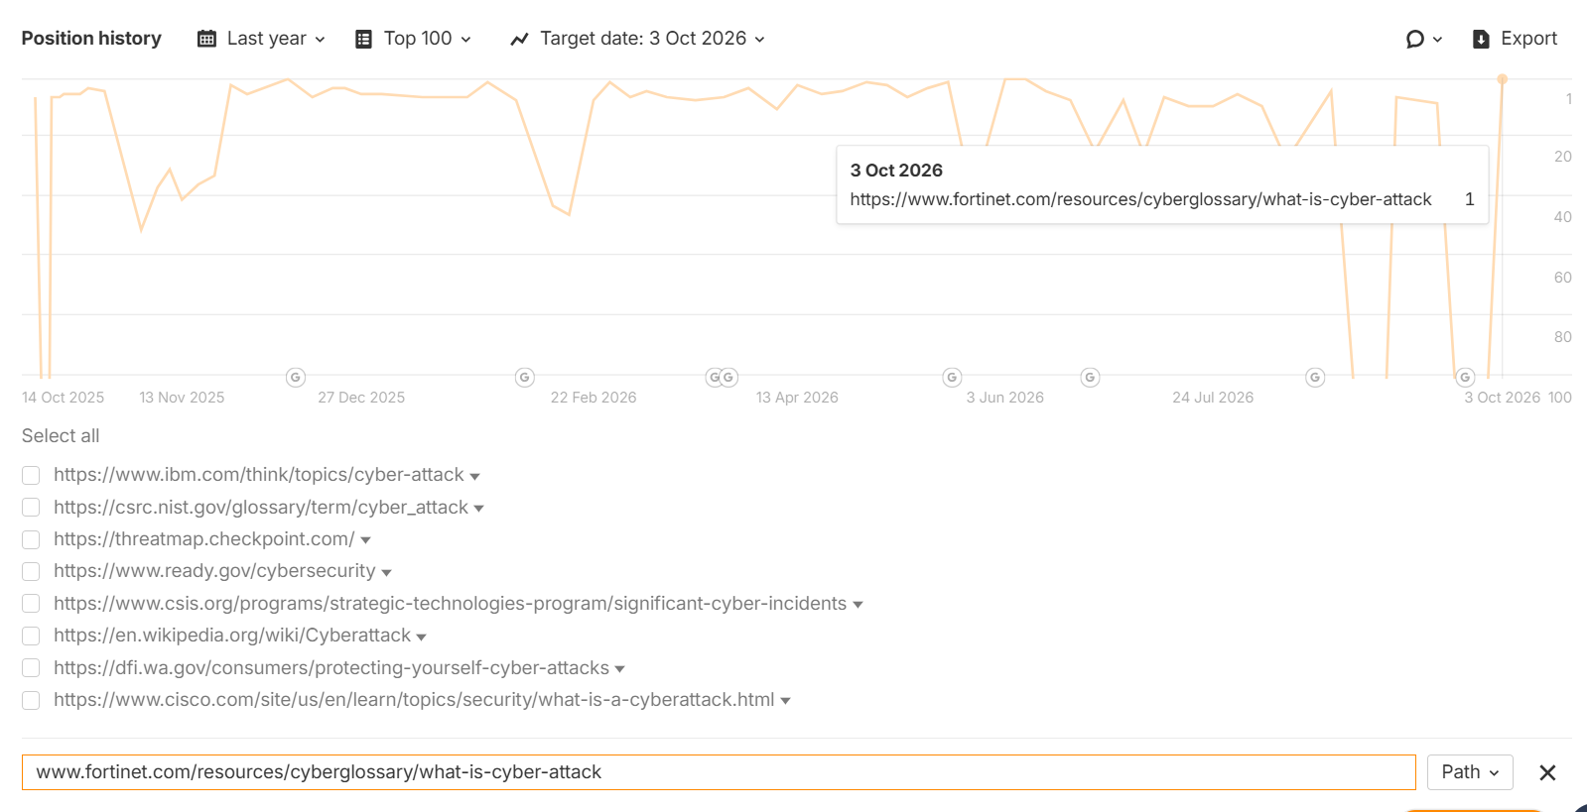
Insight: The "Cyber Attack" keyword has reached the #1 position, demonstrating continued ranking gains driven by consistent backlink acquisition.

Top Categories - Quantum & AI Cybersecurity Cyberglossary pages rank in the Top 3 positions on Page 1 post-backlink efforts.
Keyword - Post-Quantum Cryptography
Link- https://www.fortinet.com/resources/cyberglossary/post-quantum-cryptography
Position - 1
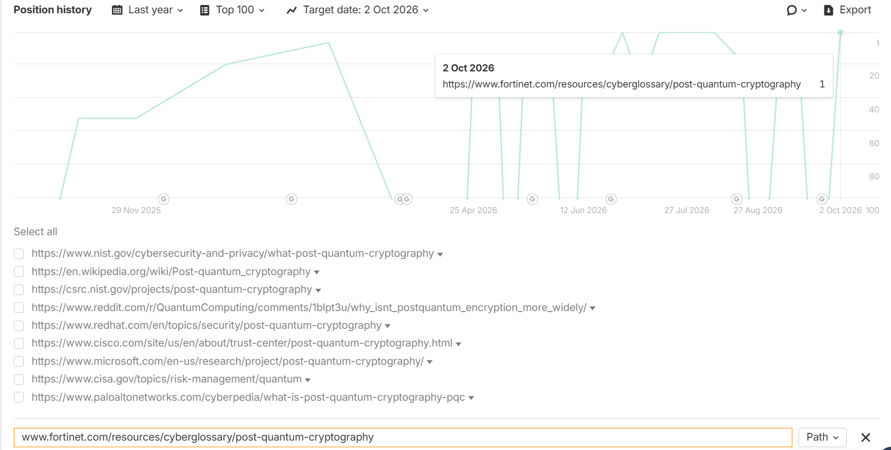

Insight: The "Post Quantum Cryptography" keyword has reached the #1 position, demonstrating continued ranking gains driven by consistent backlink acquisition.

Keyword - What is AI Security
Link- https://www.fortinet.com/resources/cyberglossary/ai-security
Position - 5

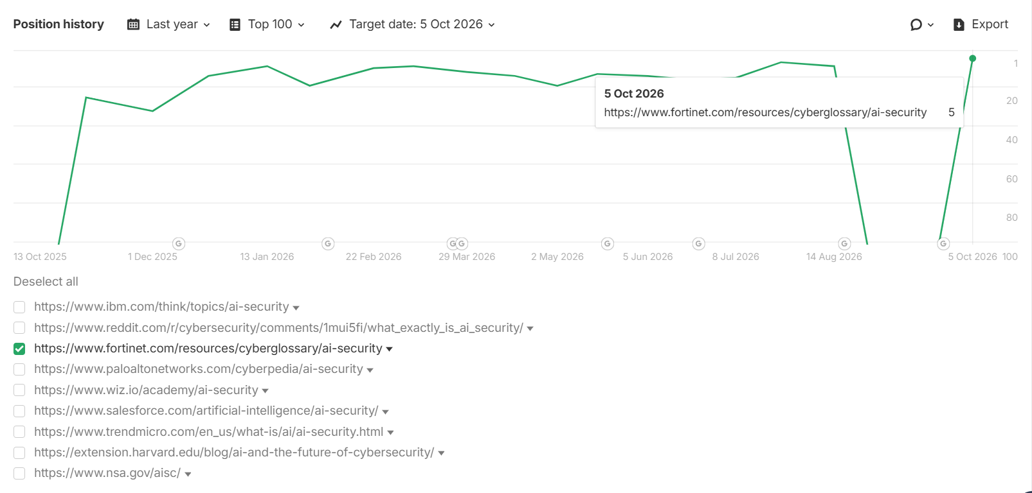

Insight: The "What is AI Security" keyword has reached a strong Top 5 position at #5, demonstrating solid search visibility and strengthening Fortinet's presence within the AI security category.

Keyword - quantum key distribution
Link- https://www.fortinet.com/resources/cyberglossary/quantum-key-distribution
Position - 1
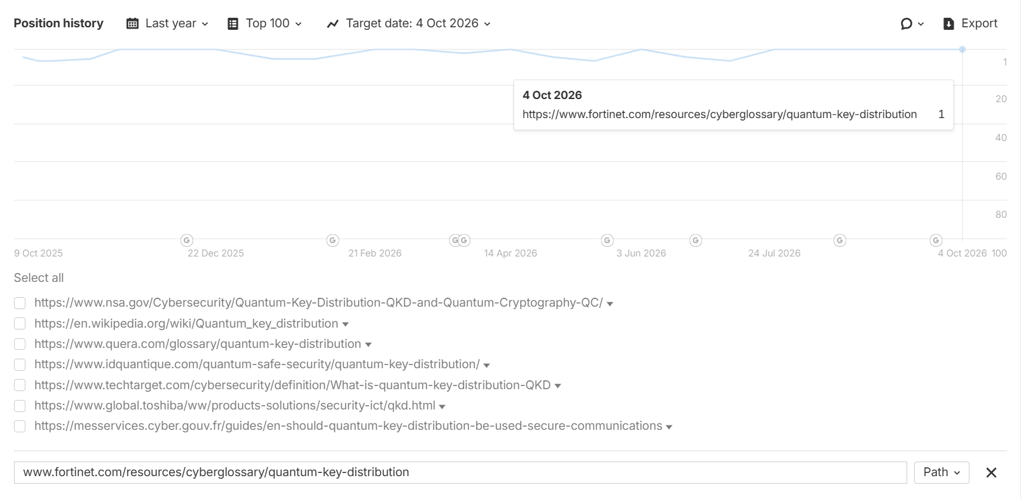

Insight: The "Quantum Key Distribution" keyword has achieved a #1 ranking, giving Fortinet maximum search visibility and strengthening its authority in the quantum cybersecurity category.

LLM Key Highlights:
Brand Visibility% Performance
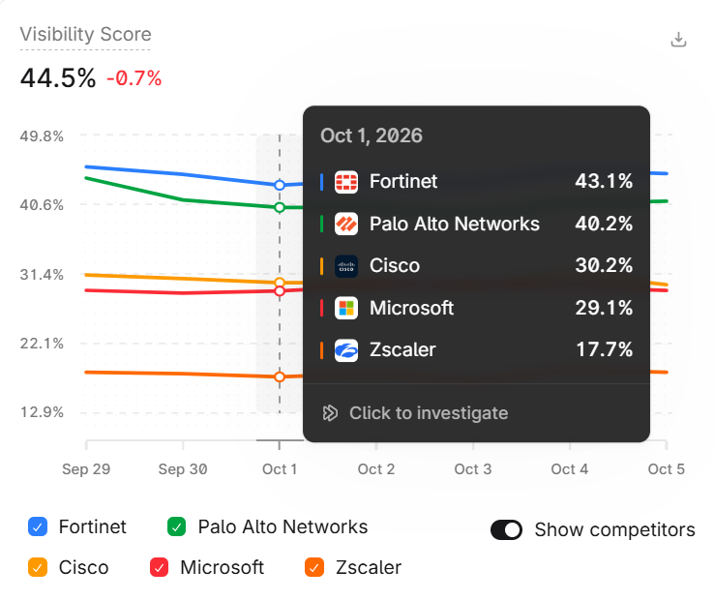
Insight: Fortinet's overall brand visibility stands in position one among the competitors at 44.5%, indicating a stable lead in AI/LLM search presence.

Category Brand Visibility Performance
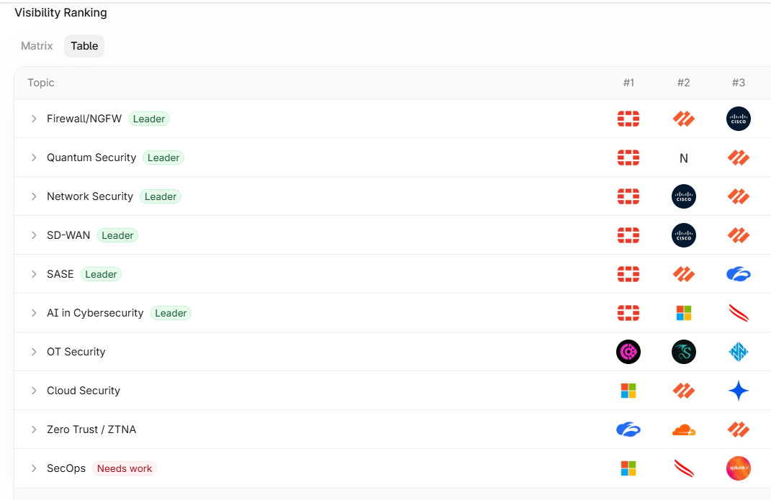
Insight:
- Fortinet leads in 6 out of 10 primary categories, achieving a 60% category leadership rate, demonstrating strong authority across the majority of key cybersecurity topics.

Category Matrix - Market Positioning
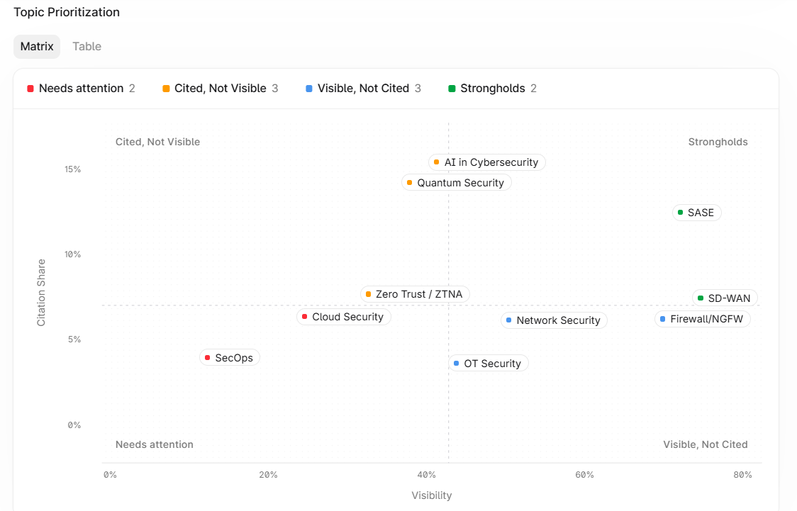
Insight: Fortinet's LLM Marketing positioning
- Citation Leaders - AI in Cybersecurity, Quantum Security & Zero Trust/ZTNA.
- Visibility Leaders - Network Security, Firewall/NGFW & OT Security
- Strongholds - SASE & SD-WAN
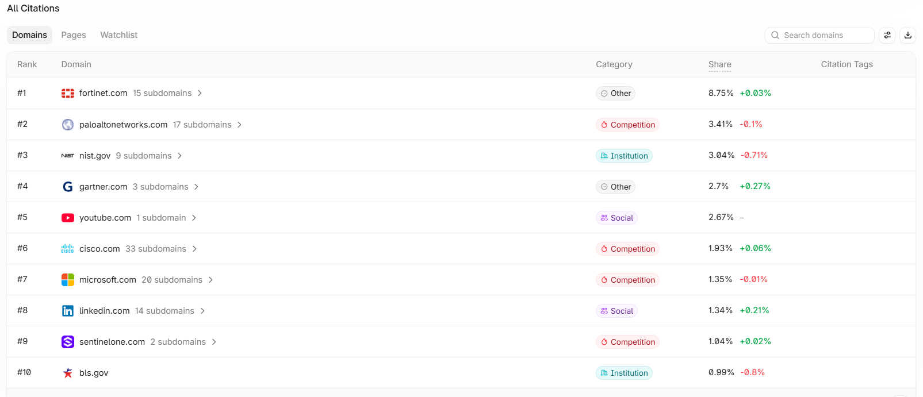
Top citation domains landscape:
Insight: Fortinet ranks #1 in the citation domains with a share of 8.71%, outperforming Palo Alto Networks and maintaining a strong lead over all major competitors.

Listicle-type Guest Posts - Third-Party Guest Posts for Brand Mentions
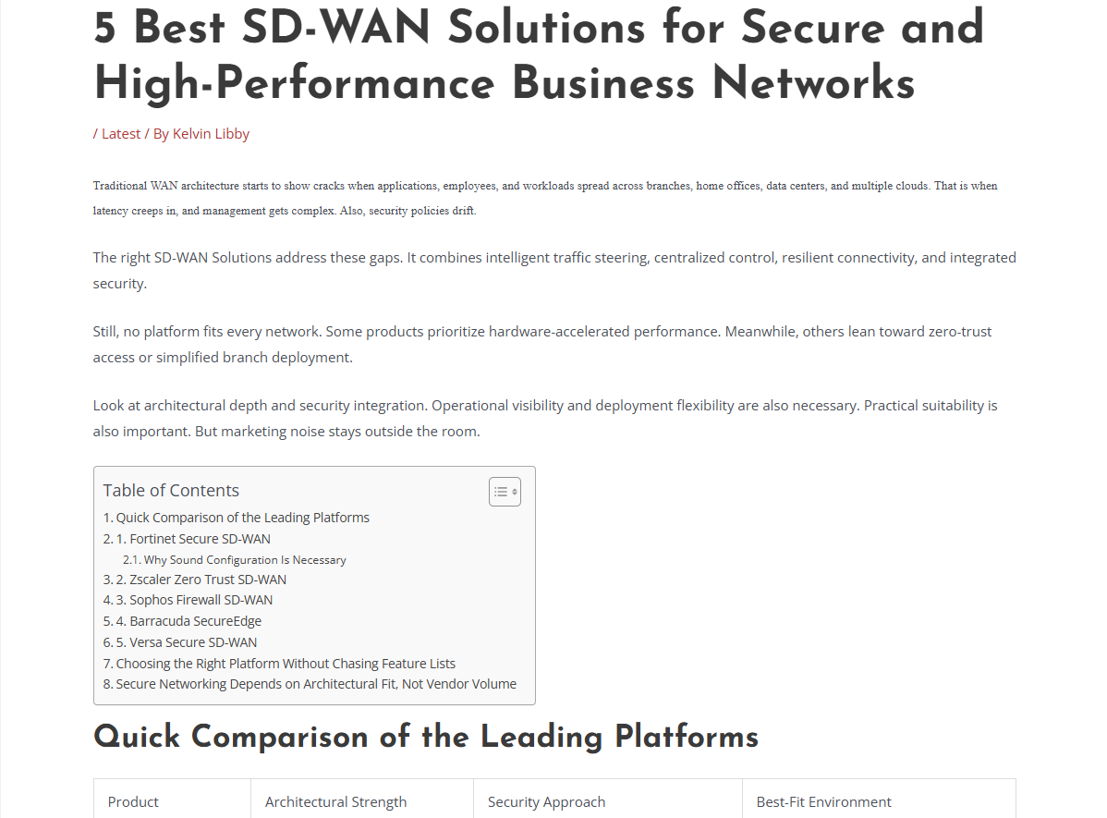
Full article -
5 Best SD-WAN Solutions for Secure and High-Performance Business Networks - Techidemics
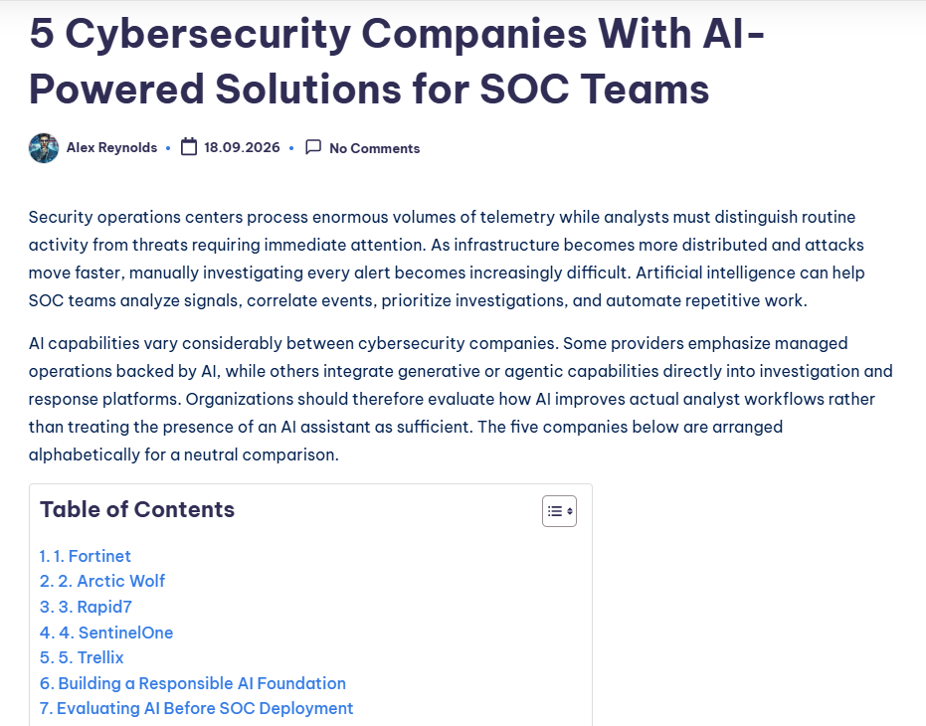
Full article - 5 Cybersecurity Companies With AI-Powered Solutions for SOC Teams - Kracensoft.com
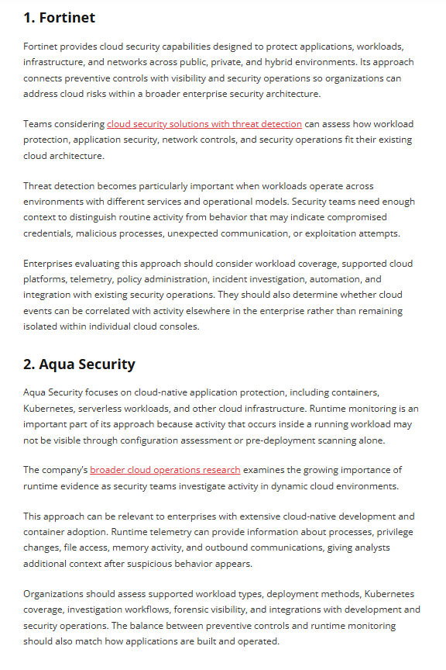
Full Article - 5 Cloud Security Providers With Built-In Threat Detection Capabilities | techslassh.com.co

Insight: Publishing listicle-style ("Best"/"Top") commercial-intent content to achieve a dual benefit: earning high-quality backlinks while increasing LLM visibility with brand mentions.

